Advanced Cyber Security Concepts

ASSESSMENT 2
SECTION A -CONCEPT APPLICATION

QUESTION1: Walk through the multi-factor verification process you would use to distinguish this as a legitimate password-reset request versus a credential-harvesting attempt.
Answer: To identify whether a password-reset request is genuine or a phishing attempt, I would follow a multi-factor verification process before taking any action.
1. Verify the Sender's Identity: Check the sender's email address, domain name, and email headers. Look for suspicious or misspelled domains and unusual sender addresses.
2. Check the Reset Link: Hover over the password-reset link without clicking it. Verify whether it redirects to the company's official website or an unknown/fake login portal.
3. Verify Through an Official Channel: Contact the IT department or employee using a known company phone number or official communication channel to confirm whether the password-reset request was actually initiated.
4. Check MFA Notifications: If an unexpected MFA approval request or authentication notification appears, do not approve it. A legitimate reset should follow the organization's approved authentication process.
5. Verify the Request Details: Check whether the employee actually requested a password reset. Unexpected urgency, threats, or requests to share OTPs are warning signs.
6. Report Suspicious Activity: If the request appears suspicious, report it to the security team, avoid clicking the link, and preserve the email for investigation.
A password-reset request should only be considered legitimate after verifying the sender, link, employee identity, and authentication process through trusted company channels. Never share passwords, OTPs, or MFA codes through email or suspicious websites.

Question2: Identify the specific header fields you would inspect to reveal a mismatch between the 'Sender' and 'Reply-To' addresses, and explain what that mismatch indicates.
Answer: To identify a mismatch between the sender and reply address in a suspicious email, I would inspect these SMTP header fields:
- From: Shows the email address displayed as the sender.
- Reply-To: Shows the email address where replies will be sent.
- Return-Path: Shows the address used to receive delivery failure messages.
- Sender: Identifies the actual sending agent or sender specified in the message header.
What does the mismatch indicate?
If the From address shows a trusted company, but the Reply-To address belongs to an unknown or different domain, it may indicate a phishing attempt. The attacker may be trying to make the email look genuine while directing the victim's reply to the attacker's email address.
Example:
Header | Email address
From | support@amazon.com
Reply-To | fakehelp@gmail.com
Return-Path | bounce@suspicious-domain.com

QUESTION3: Explain how 'display name spoofing' can still successfully deceive users even when the underlying domain passes SPF/DKIM checks.
Answer: Display name spoofing is a phishing technique in which an attacker uses the name of a trusted person or company to trick users into believing that an email is genuine.
Even if an email passes SPF and DKIM checks, it can still be a phishing email because these checks mainly verify the sending domain and email authentication, not whether the displayed sender name is trustworthy.
Example:
Email field Value
Display Name Amazon Customer Support
Email Address attacker123@gmail.com
SPF/DKIM Passed
The user may see "Amazon Customer Support" and trust the email without checking the actual email address.
How it deceives users:
- The attacker uses a trusted company name as the display name.
- The email passes authentication for the attacker's own sending domain.
- The user sees the familiar company name and believes it is genuine.
- The user may click a fake link or share personal information.

QUESTION 4: Describe the strategic role of user awareness training as a 'human firewall' working alongside technical email filtering.
Answer: User awareness training acts as a Human Firewall by teaching employees how to identify and avoid phishing attacks. Even if a company has strong email filtering, some harmful emails may still reach employees.
Strategic role of user awareness training:
- Identify phishing emails: Employees learn to recognize fake emails, suspicious links and attachments.
- Prevent data theft: Employees avoid sharing passwords, OTPs and confidential information.
- Report suspicious emails: Employees learn how to report phishing attempts to the IT security team.
- Reduce human errors: Training helps prevent accidental clicks on harmful links or downloads.
- Improve security culture: Employees become more careful and responsible when using company systems.

Technical filtering vs Human Firewall
Email filtering | Human Firewall
Automatically detects suspicious emails. | Employees identify suspicious messages.
Blocks spam and malicious attachments. | Avoids clicking suspicious links.
Uses technical security tools. | Uses employee knowledge and awareness.
Works automatically. | Requires regular training.

QUESTION 5: Outline the immediate sequence of host isolation and credential revocation steps you would take.
Answer: If a system is suspected of being compromised, I would follow these immediate steps to isolate the infected host and revoke stolen credentials to prevent further unauthorized access.
1. Identify the Compromised Host: Identify the affected employee's device using security alerts, IP addresses, endpoint logs, and suspicious login activity.
2. Isolate the Host: Disconnect the compromised device from the company network using Endpoint Detection and Response (EDR) or network controls. This prevents the attacker from communicating with other systems.
3. Disable the Compromised Account: Temporarily disable the employee's account in the Identity and Access Management (IAM) system to stop further unauthorized access.
4. Revoke Active Sessions and Tokens: Revoke all active refresh tokens, sign-in sessions, and application sessions. Invalidate access tokens wherever supported to terminate the attacker's session.
5. Reset Password and MFA: Reset the employee's password and securely re-register MFA. Remove any suspicious authentication methods or unknown registered devices.
6. Block Malicious Access: Block suspicious IP addresses, investigate unauthorized connections, and restrict access to sensitive systems such as the HR database.
7. Verify and Monitor: Review authentication and network logs to confirm that the attacker has lost access. Monitor the account and affected device for further suspicious activity.
Host isolation and credential revocation help contain the incident, prevent lateral movement, and stop attackers from accessing company resources using stolen credentials.

QUESTION 6: Identify the NIST Cybersecurity Framework (CSF) category that mandates organizational training to mitigate social engineering risks.
Answer: NIST Cybersecurity Framework (CSF)
The correct category is Protect – Awareness and Training (PR.AT).
- It focuses on training employees about cybersecurity risks.
- It teaches employees to identify phishing emails, fake links, and social engineering attacks.
- It helps employees understand their security responsibilities and follow safe practices.
Example: Training employees not to share passwords or OTPs and how to report suspicious emails.
Conclusion: The PR.AT (Awareness and Training) category helps reduce social engineering risks through employee education.

SECTION B- PRACTICAL CODING TASK

TASK 1: Email Authentication Check

1. Retrieving and Analyzing the SPF Record
Sender Policy Framework (SPF) specifies which mail servers are authorized to send email on behalf of your domain. It is published as a DNS TXT record at the root of the domain.
CMD :
USING DIG: dig +short TXT example.com
USING NSLOOK: nslookup -type=TXT example.com
SAMPLE OUTPUT: "v=spf1 include:_spf.google.com ~all"
2. Retrieving and Analyzing the DMARC Record
Domain-based Message Authentication, Reporting, and Conformance (DMARC) relies on SPF and DKIM to prevent spoofing. It tells the receiving mail server what to do if an email fails authentication checks. DMARC is always published as a TXT record at the _dmarc subdomain.
USING DIGl: dig +short TXT _dmarc.example.com
USING NSLOOKUP: nslookup -type=TXT _dmarc.example.com
SAMPLE OUTPUT: "v=DMARC1; p=reject; rua=mailto:dmarc-reports@example.com; pct=100"

3. DMARC Policy Levels and Spoofing Resistance
The policy tag (p=) dictates how receiving mail servers handle emails that fail DMARC verification. There are three distinct policy levels:
Policy Value (p=) | Enforcement Behavior | Spoofing Resistance Assessment
p=none | Monitor Only: Failing emails are delivered normally to the inbox. It is used primarily for collecting analytics via reporting (rua=). | Very Low / Vulnerable: Attackers can easily spoof your domain; recipients will see the fake email normally.
p=quarantine | Suspicious Handling: Failing emails are treated with suspicion and diverted directly to the recipient's Spam/Junk folder. | Moderate: Spoofed mail is blocked from the primary inbox, reducing successful phishing/spoofing risks.
p=reject | Strict Enforcement: Failing emails are outright blocked and dropped at the mail server level before they ever hit the mailbox or spam folder. | Maximum / High: Complete defense against direct domain-spoofing attacks.

4. Documenting Enforcement (p=reject)
To formally assess and document whether a domain enforces a p=reject policy and what it means for spoofed mail:
- Enforcement Check: Look at the retrieved DMARC string. If it contains p=reject, the domain has implemented the strictest policy tier.
- Impact on Spoofed Mail:
  - When an external threat actor attempts to send an unauthenticated email spoofing the domain's header (From: admin@example.com), the receiving mail server evaluates SPF/DKIM alignment.
  - Because the attacker's sending server is not listed in the domain's SPF record and lacks a valid cryptographic DKIM signature, the DMARC check fails.
  - With p=reject active, the destination mail server drops the message connection entirely. The attack never reaches the target user, completely neutralizing domain-impersonation spoofing attacks.

TASK 2: Phishing Email Header Analysis

1. Locate the Header Block
Open the .eml file in any text editor (Notepad, VS Code, Nano) and inspect the top block of text before the message body.
2. Extract the Originating IP (Received Headers)
Email headers are read from bottom to top. The bottom Received header shows where the email originated, while the top one shows your mail server.

Look for the bottom-most Received: line: Received: from mail.attacker-domain.com (mail.attacker-domain.com [203.0.113.50])
Extracted Originating IP: 203.0.113.50

3. Check the IP via CLI (Blacklist/Reputation Lookup)
Query a DNS-based Blackhole List (RBL) using dig or nslookup to check if the IP is flagged for malicious activity (e.g., spamhaus.org): dig +short 50.113.0.203.zen.spamhaus.org TXT

4. Check for Header Mismatches (Sender vs. Reply-To)
Phishing emails often attempt to deceive recipients by misaligning sender addresses:
- From: Header: support@yourbank.com (Spoofed display name/domain)
- Reply-To: Header: attacker-phishing-drop@free-mail.com (Where replies actually go)

TASK3: Proxy Log Exfiltration Check
1. Filter Proxy Logs for HTTP POST Requests
Use command-line text processing tools (grep, awk) to isolate POST traffic, which is typically used to transmit credentials or stolen data outward.
CMD:
grep -i "POST" proxy.log

2. Identify Non-Standard External Destinations & Cross-Reference IOCs
Review the filtered POST requests for external domains or IP addresses. Flag any entry matching the suspicious infrastructure identified in Task 2 (e.g., IP 203.0.113.50 or attacker-domain.com).
Search Command: grep -i "POST" proxy.log | grep -E "203.0.113.50|attacker-domain.com"

3. Summary of Flagged Exfiltration Requests
Timestamp | Source IP (Internal) | Destination Domain / IP | Action / Method
2026-06-06 14:22:10 | 192.168.1.105 | mail.attacker-domain.com (203.0.113.50) | POST /auth/login.php (Suspicious payload)

TASK4: Attack Simulation and Mail Flow Defense
1. Generating a Credential Harvester via SET
The Social Engineering Toolkit (SET) allows penetration testers to clone login portals to test organizational susceptibility to credential harvesting.
Execution Steps (CLI):
- Launch SET with administrative privileges: sudo setoolkit
- Select 1 for Social-Engineering Attacks.
- Select 2 for Website Attack Vectors.
- Select 3 for Credential Harvester Attack Method.
- Select 2 for Site Cloner (or choose a built-in template like the corporate login portal).
- Enter your listener IP (attacker server) and the target URL to clone (e.g., your organization's SSO login page).

Terminal & Harvester Page Reference:
- Terminal Output: Shows the web server initializing on port 80/443 and logging incoming HTTP GET/POST captures.
[*] Starting web server on port 80...
[*] Information Security Awareness - Credential Harvester Active
[*] Waiting for user interaction...

2. Configuring Mail Flow Defenses (External Warning Banner)
To disrupt phishing attempts that mimic internal communications (as analyzed in Tasks 2 and 3), configure an Exchange Online or mail gateway rule to inject a warning banner into all inbound external emails.
Mail Flow Rule Configuration (Exchange / Microsoft 365):
- Name: Prepend External Sender Warning Banner
- Apply this rule if:
  - The sender is located $→$ Outside the organization
- Do the following:
  - Prepend the message with this disclaimer: <div style="background-color:#FFF4CE; padding:10px; border-left:4px solid #FFC000; font-family:sans-serif; font-size:12px; color:#333; margin-bottom:15px;">
<b>CAUTION:</b> This email originated from outside the organization. Do not click links or open attachments unless you recognize the sender and know the content is safe.
</div>

3. Impact Analysis: How the Defense Blocks the Attack
Implementing an external warning banner directly counteracts the attack chain demonstrated in Tasks 2 and 3:
- Breaking the Illusion of Trust: In Task 2, a spoofed email tricked the user into believing a message came from a trusted internal source or verified partner. The injected warning banner instantly alerts the recipient that the message originated externally.
- Preventing Credential Submission (Task 4): When the user clicks the link leading to the SET credential harvester, they are already psychologically primed by the banner to scrutinize the sender's legitimacy, sharply reducing the likelihood of entering credentials.
- Stopping Exfiltration (Task 3): By intercepting the initial phishing vector at the inbox level, the subsequent unauthorized HTTP POST requests and data exfiltration paths observed in the proxy logs are entirely prevented.

SECTION C- MINI CAPSTONE PROJECT

Mini Project: Apex Financial — Spear-Phishing & Session Hijack Incident Response

THIS IS THE REPORT FOR THE PROJECT

SECTION D- AI-AUGMENTED LEARNING

STEP 1 – Build with AI
1. Open Kali Terminal
Open the Terminal in Kali Linux.
Type: mkdir email-checker
cd email-checker
This creates a folder named email-checker and opens it.
2. Create the Bash script
Type: nano email_checker.sh
A text editor will open.
Copy the following script into it:

#!/bin/bash

# Email Sender and Reply-To Domain Checker

if [ "$#" -ne 1 ]; then
echo "Usage: $0 input_file.txt"
exit 1
fi

if [ ! -f "$1" ]; then
echo "Error: Input file not found."
exit 1
fi

python3 - "$1" <<'PY'
import sys
import re
import ipaddress
from email.parser import Parser
from email.utils import parseaddr

filename = sys.argv[1]

with open(filename, "r", encoding="utf-8", errors="replace") as file:
content = file.read()

# Each email header block is separated by ---EMAIL---
blocks = re.split(r"(?m)^---EMAIL---\s*$", content)

flagged = []

for number, block in enumerate(blocks, start=1):
if not block.strip():
continue

msg = Parser().parsestr(block)

sender = parseaddr(msg.get("From", ""))[1]
reply_to = parseaddr(msg.get("Reply-To", ""))[1]

sender_domain = sender.rsplit("@", 1)[-1].lower() if "@" in sender else ""
reply_domain = reply_to.rsplit("@", 1)[-1].lower() if "@" in reply_to else ""

# Find the first IP address in the Received headers.
origin_ip = "Not found"

for received in msg.get_all("Received", []):
match = re.search(r"\b(?:\d{1,3}\.){3}\d{1,3}\b", received)
if match:
try:
origin_ip = str(ipaddress.ip_address(match.group()))
break
except ValueError:
continue

if not sender or not reply_to:
print(f"Email {number}: Skipped (Sender or Reply-To missing)")
continue

if sender_domain != reply_domain:
flagged.append((number, sender, reply_to, origin_ip))

print("\n===== EMAIL SECURITY REPORT =====")

if flagged:
for number, sender, reply_to, ip in flagged:
print(f"\nEmail Number: {number}")
print(f"Sender: {sender}")
print(f"Reply-To: {reply_to}")
print(f"Originating IP: {ip}")
print("Status: FLAGGED - Domain mismatch")
else:
print("No domain mismatches found.")

print(f"\nTotal flagged emails: {len(flagged)}")
PY
4. Save the script
In Nano:
- Press Ctrl + O.
- Press Enter.
- Press Ctrl + X.
Now make the script executable: chmod +x email_checker.sh
5. Create a sample email header file
Type: nano sample_emails.txt
Paste this sample:

From: IT Admin <admin@company.com>
Reply-To: support@gmail.com
Received: from mail.company.com (10.0.0.5)
Received: from sender.example.net (8.8.8.8)

---EMAIL---
From: HR Department <hr@company.com>
Reply-To: hr@company.com
Received: from mail.company.com (192.168.1.10)
6. Run your script
Type: ./email_checker.sh sample_emails.txt
You should see a report similar to this:
===== EMAIL SECURITY REPORT =====

Email Number: 1
Sender: admin@company.com
Reply-To: support@gmail.com
Originating IP: 10.0.0.5
Status: FLAGGED - Domain mismatch

Total flagged emails: 1

STEP 2 – Test and debug WITHOUT AI
This is the important practical part. Your teacher wants you to find at least one problem in the AI-generated script and fix it yourself.

7. Test the script
Run: ./email_checker.sh sample_emails.txt
8. Investigate and fix it yourself
Now follow these steps without asking AI to write the correction:
- Open the script: nano email_checker.sh
- Find the section containing the comment: # Find the first IP address in the Received headers.
- Study the loop that searches for an IP address.
- Think about how to change the logic so that it skips private IP addresses and selects a globally routable public IP address instead.
- Use your Python knowledge or your own notes to make the correction.
- Save the file and run the test again:
- Check whether the result now reports 8.8.8.8.

9. Test one more case
Create another test file: nano test2.txt
Paste:
From: Security Team <security@company.com>
Reply-To: unknown@yahoo.com
Received: from server.example (1.1.1.1)

---EMAIL---
From: Manager <manager@college.edu>
Reply-To: manager@college.edu
Received: from server.example (8.8.8.8)
Save and run: ./email_checker.sh test2.txt
Check these things:
- First email should be flagged.
- Second email should not be flagged.
- The report should show the Sender, Reply-To, and IP address.

Bash script:
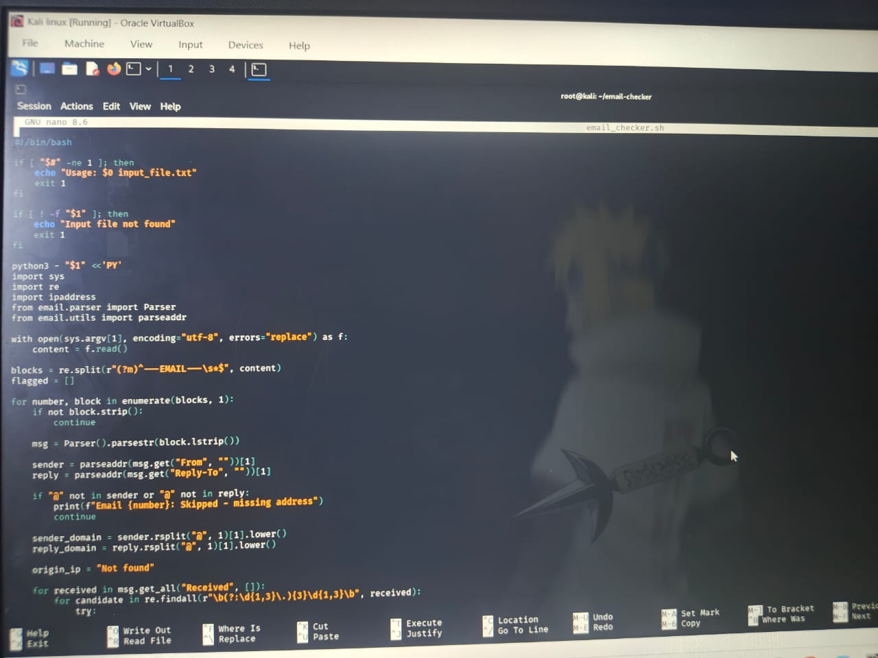
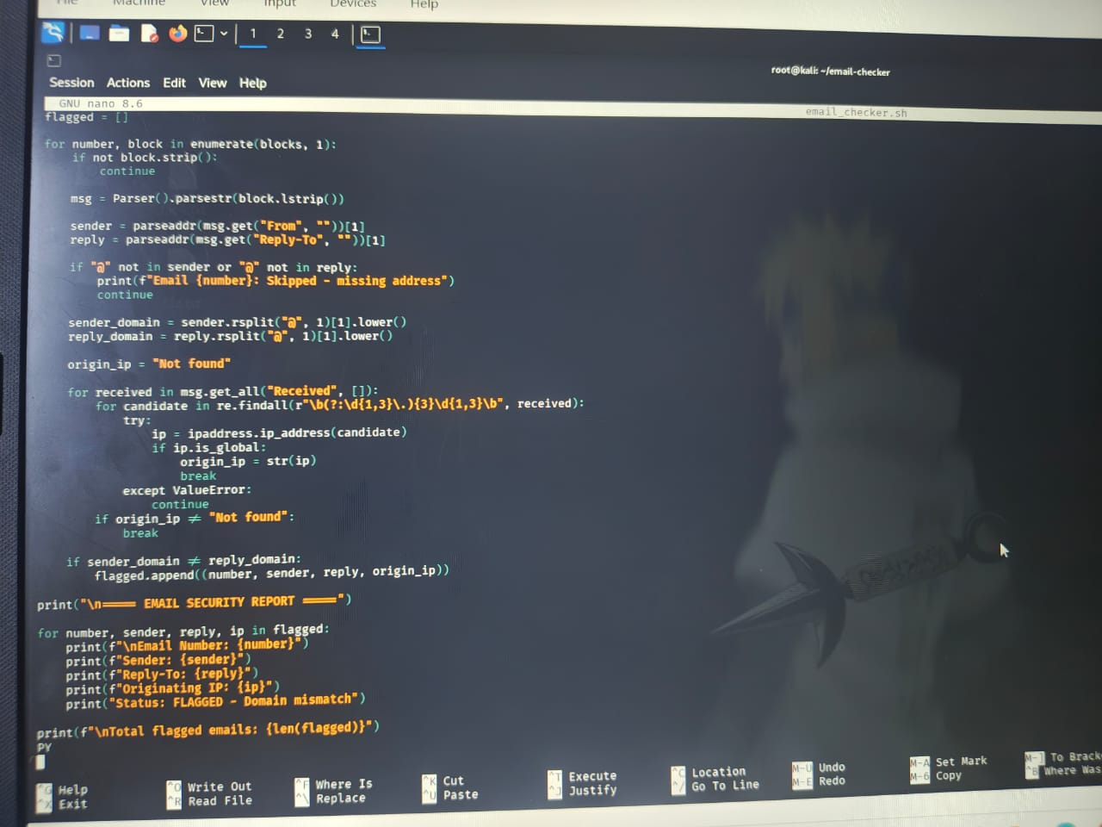
Sample input file:
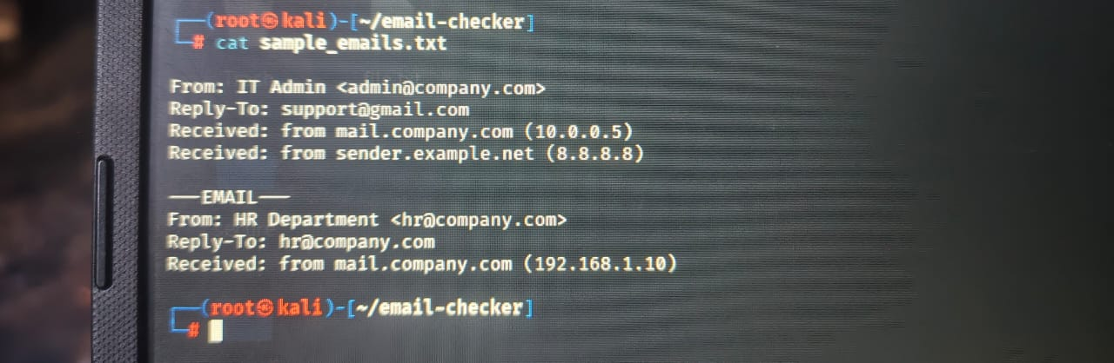

First test output:
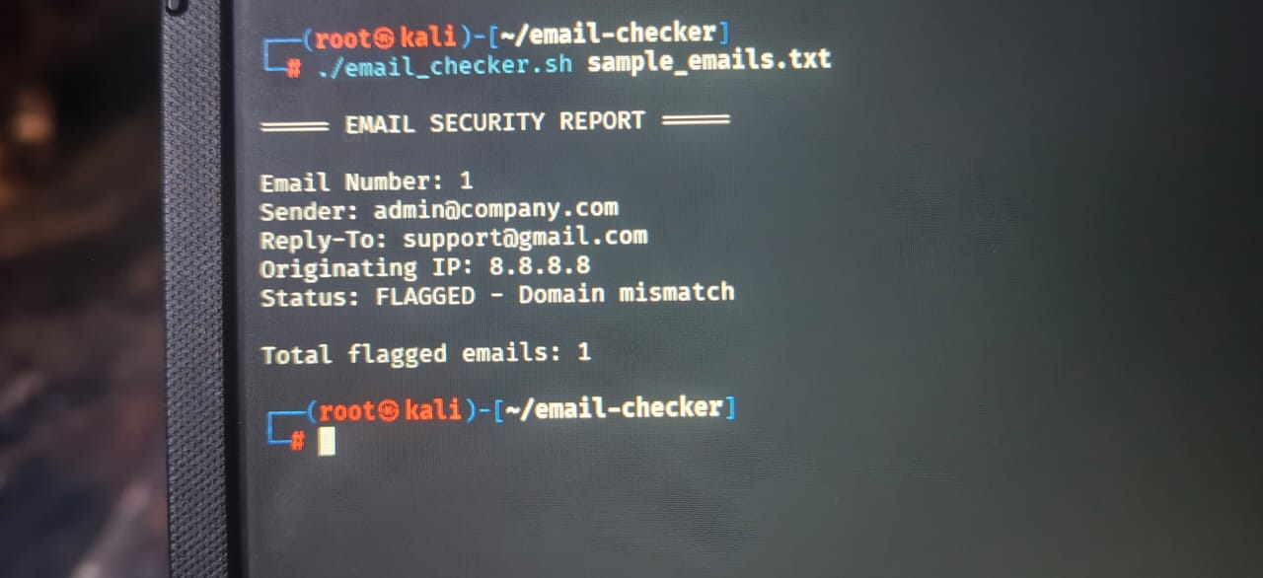
Change the cmd to it msg = Parser().parsestr(block.lstrip()) to not block parser

Final testing output:


